Comprehensive Creative Technologies Project: Project Title (in Tahoma, 24pt)

**Callum Bloys**  
[callum2.bloys@live.uwe.ac.uk](mailto:my.email@live.uwe.ac.uk)Supervisor: Marcus Lynch

Department of Computer Science and Creative Technology

University of the West of England  
Coldharbour Lane  
Bristol BS16 1QY

**Abstract**

This Project is a puzzle game in VR that uses an interesting mechanic which is forced perspective illusions. The idea of the project is to create illusions and use those to work out puzzles. This provides mental challenges to the player and can be worked upon to add other illusions. The aim of this project is a VR project using an illusion called forced perspective to create puzzles which is created in Unity.

Verdana, 9pt. This is a top line description of your project, not an introduction (that comes later). Please summarise your project, giving a bird’s eye view of your application/ software/ animation/ etc.   
What is the project? What is its aim? How was this realized in practice? Any key results/ insights that might benefit other professionals in the field? Don’t try to write anything new here, just repeat the main points achieved in your project. Short summaries like this are for other professionals who just want to get to the core of your work without having to read the whole report.   
Note: the abstract is not included in the word count.

**Keywords**: Superliminal, VR, puzzle, forced perspective,

**Brief biography**

The idea for the project was decided when researching VR and the capabilities it has and will have in the future, I've had an interest in VR since it launched and have always found realism in games intriguing. Another reason for my interest is due to VR’s massive growth as it is becoming increasingly popular. I believe VR to be a big interest of mine due to VR being a completely different experience as it puts the player in more control and allows the player to feel as if they are within the world.

**How to access the project**

Project github link: <https://github.com/callumbloys/Dissertation_VR_Project.git>

Verdana, 9pt. Please put down any **project URLs** and/or details of where/how to access your project, and the ***URL of your final video***. If we need to see any back end / administration interface please provide us with necessary passwords and URLs to access this. Basically, what we cannot access will not be considered for marking. You can change the passwords after you receive your mark.

**1. Introduction** 400 words

VR has become a growing market within the game industry and other industrys. VR allows people to feel like there somewhere they’ve dreamt of being and would or could never visit it also gives the player a feel of perspective compared to a normal game on your TV or monitor as the player can see the world around them for what it would be if they were there and giving the player a sense of scale. To this day VR is still growing and new VR headsets are in development making experiences more and more realistic.

The idea of this project stemmed from the interest in virtual reality and how it can make the player feel, the idea of making VR realistic and as close to real life as possible is very interesting and therefore the idea was created. Then the focus was on what this VR game shall entail. The decision was for the project to explore puzzles as they test the players mind, and it is a popular mechanic in games. After looking at many different puzzle mechanics and games one stood out and that was 'Superliminal'. ‘Superliminal’ uses forced perspective to create its puzzles, in this game the objects scale to different sizes based on the perspective of the object from the player, the closer the player is to the object when picked up the bigger it is and vice versa.

The VR experience will hopefully be created to minimize motion sickness therefore making it more pleasant for players. This was decided due to motion sickness being a big problem for VR and can put people off playing VR. The game is set within a temple in the jungle and the ability to use forced perspective will be present in this game.

The project will consist of:

* Smooth VR which provides a good experience with minimal motion sickness.
* Well thought through puzzles using forced perspective.
  1. **Project objectives**
* Implement smooth and easy to use VR controls.
* Implement forced perspective mechanic and make it fit the theme of the game.
  1. **Key deliverables**
* A Unity project that consits of the VR game.

**2. Literature review** 600w

**2.1 Risks and problems of VR and how to overcome them.**

When researching the risks and problems VR can cause many issues these include back pains and neck pains these are due to the weight of the headsets. “In addition, the heavy VR headset may increase the burden on the cervical spine, risking greater neck strain. Sciencedaily.com, (2020)” Other issues include eye strain and motion sickness. When researching motion sickness there seemed to be ways in which motion sickness can be reduced but not removed. One way in which this can be reduced is possibly using a setting which when toggled on makes the player teleport forward instead of walking, or making the player walk slower as after lots of research it seems adding teleportation instead of walking reduces the chance of motion sickness. ” Teleportation is a locomotive mechanism that helps to avoid VR motion sickness. If you get rid of the movement visualization, then you’ll prevent VR sickness. Arvilab.com, (2018)”. During research there also was a survey found online that said more than half suffered motion sickness “The survey, put together by VR Heaven and which polled almost 300 respondents, found that more than half (57.8%) said they experienced motion sickness in VR at some time.”

Another way of doing this is implementing a setting to allow the player to sit down instead this can significantly help with motion sickness and prevent back ache and leg ache when having long play sessions. researching this was very important as motion sickness is a very big issue and is common. "With contemporary commercially available VR systems, the incidence of motion sickness after only 15 minutes is anywhere from 40 to 70 percent," Thomas Stoffregen, a kinesiologist at the University of Minnesota, told Inside Science. He even said that for some applications, almost 100 percent of users get sick. Helen A. Lee, (2020)”.

**2.2** **Setting up VR and implementing VR.**

When researching Setting up and implementing VR into the Unity engine there were a vast array of videos and tutorials available and most of them suggested Unity as a better option over anything else “Many developers claim Unity is a good choice because of ease of use. Circuitstream, (2021)” videos were the main help when learning how VR is set up in Unity. From researching step by step how to set up VR it seems like once the settings when setting up VR are correct, hand tracking and head tracking is already set up and easy to use and edit. Research into hand tracking and head tracking was made helping to understand setting up VR. Also researched was XR which is used to set up and create VR XR is essential when making VR games this includes the XR rig which is essentially the player from research it seems the XR rig is a box which is the player within this XR rig is a camera and two controller left hand and right hand both have separate controls, XR rig is the room of which the player is in and the area the player can freely move around within.

**2.3** **Forced perspective mechanic**

Research was also done on forced perspective which will be the puzzle mechanic in this game, forced perspective will need to create to a good standard as this will be used to overcome obstacles and traverse the level research was also done in level design in VR as well due to VR environments being important to add.

**3. Research questions** 250w

1. How will the project overcome the issues like motion sickness and other side effects as a result of using VR?
2. How will the forced perspective mechanic be improved compared to other forced perspective games?
3. What challenges are there when setting up and using VR for this project?

**4. Research methods** 400w

Secondary research was carried out using articles and papers to conduct the appropriate research needed when researching the possible issues with VR, and how they could be overcome. Qualitative research was used to undergo this, secondary research methods were employed due to the vast amount of prior research undertaken on VR and video games as a whole, especially in the safety aspect of VR. The safety in VR seems to be a particularly important topic that is discussed in many articles and papers that have been looked through. Also, instead of doing primary research to create a survey or questionnaire there were surveys online addressing VR issues and motion sickness etc. which were used so primary research via surveys was not required, from these surveys it was concluded that motion sickness and other pains are big common issues when using VR and so have a massive impact on VR in the future that's why looking into this was so crucial before developing anything in VR. Looking at articles, papers etc. has opened a lot of ideas that could be implemented to overcome this issue.

Looking at previous ways forced perspective has been implemented helps provide insight on how to approach and change this mechanic and provides a good basis for the project. Research was also done to see how forced perspective could be improved and or changed in order to do this YouTube videos were used to see how ‘Superliminal’ and ‘Tale of Scale’ both uses forced perspective uniquely. Also ‘Tale of Scale’ is available for free on kongregate (link in bibliography) which allows for it to be seen and played giving more understanding on how this mechanic works.

Last of all secondary research and qualitative research was also utilized to discover how VR can be set up and all the tools available etc. one thing researched is how easy it is to set up, when setting up the VR on Unity there were some difficulties at first but there are a wide variety of videos, these videos help with the setup which makes it a lot easier to set up VR. VR in Unity has a lot of tools and caters for VR with a lot of help so making VR shouldn't be too much of a challenge.

**5. Ethical and professional principles** 350w

This research did not require human participants to be involved as secondary research was used instead and surveys/questionnaires were found online. The project itself does not pose any ethical concerns however on the physical health side it can negatively affect some individuals if used this is due to motion sickness and neck ache etc. but these can be mitigated through many different methods.

One issue that could come from this project once completed is motion sickness, this could make someone ill. To minimise this there could be a motion sickness mode that can be toggled on and off allowing for a less nauseous experience. People that get nauseated very easily and or suffer from motion sickness could suffer from this project however with a motion sickness setting this could help alleviate the issue for some people.

Another issue that could pose a danger to players is objects being in the way etc. to fix this there may be a certain space size required to play which would make it so players wanting to play will have to find a bigger space to play similar to the ‘Job Simulator’ VR game which the game requires you have a big play area to play. The mitigate this the XR rig will be used which is the play area that the plyers sets up a check could be made which requires a certain room space to play this would help reduce injuries.

An issue that could be of concern is aches, pains and visual problems can be caused from long VR play times this would be a problem that could easily be fixed by reducing play time and having text in the game warning players not to play for a long time and to take breaks. This issue can’t be mitigated very well though as not much can be done to the game to reduce this. “One hour is considered best to avoid vision problems and developmental issues. Krueger, K.K. and Corso, K.C. (2022)”.

**6. Research findings** 600w

**4.1 Similar Games.**

Research has been done to find games that use the forced perspective mechanic or mechanics like this, there are very few games that use this mechanic and even less that use it in VR one of these is a very popular game called ‘Superliminal’ as shown by the image (Figure 1). Some smaller games use this mechanic too; most are very small and have not published them as full games, instead as short demos made in Unity. One of these games is ‘Tale of Scale’. This game uses a hand that the player uses to pick up objects and resize them similar to Superliminal as shown by the image (Figure 2). both of these use the same mechanic, and both look very similar, however there is one game that use forced perspective very differently this game is called ‘Perspective’ this game is a 3-dimensional third person puzzle game that uses a 2-dimensional platform game, in this game the player controls a 2D Character through a 2D screen that changes based on the angle of the players camera in 3D space.

**4.2 VR Games.**

Research has also been made into how VR Games are created and the pros and cons of creating this project in VR. The pros of making a game in VR are that the player can feel more within the game than they would if it wasn't made in VR and the game can be more detailed and real as well as that the market for VR is rising “The number of global virtual reality device shipments was 13. 48 million units in 2020, and it is expected to reach a volume of 112. 62 million units by 2026, registering a CAGR of 33. 85% over the forecast period (2021–2026). Reportlinker, (2021)”. This shows the market will carry on rising so VR will become more and more popular. The cons however is the expense of VR which has been said in many articles and forums which shows the issue surrounding it however with the new Oculus Quest 2 the price has decreased for VR but even with the Oculus Quest 2 the prices are still high. Another con that seems to be a common issue is comfort as a lot of people don't find VR comfortable, there's a lot of reasons for this for example the weight of the headset “Motion sickness isn't VR's only comfort issue. Our necks and eyes simply weren't designed to wear headsets on a regular basis.”

**4.3 Setting Up VR in Unity.**

Research has also been made into what is needed to set up a VR game and what engine is best for this. After a lot of research, it has been decided that Unity will be used to create this project due to its many VR tools and Unity has its own VR setting when creating the project. The decision to use Unity was also due to a lot of other forced perspective games like Superliminal and Tale of Scale using Unity to create their games. Research made it possible to set up VR in Unity, videos were used and then Unity was opened and then set up for VR, which was not too difficult, to do this project setting was opened and then within project settings select ‘Install XP Plugin Management’ this will install the correct settings for VR.

**4.4 motion sickness and other issues in VR.**

One of the most important things researched was motion sickness. This is due to the fact this is usually the main issue that puts people off playing VR. a lot of games mitigate this problem using certain settings the player can change to help with nausea. these can include:

1. “Turning off ‘head bobbing.’
2. Turning off motion blur.
3. Upping the field of view.
4. Adjusting sensitivity of movement. Whittaker, K.W. (2019) “

or by adding a seated mode which can allow the player to sit down if playing for prolonged amounts of time to reduce the chance of getting motion sickness and to help with leg ache.

**7. Practice** 2500 words

The development of this project can be split into 3 main stages: Researching and planning VR, implementing an engaging and realistic VR and player experience and environment and puzzle developing. Each one of these stages are crucial to creating this project.

**7.1 Researching and planning VR**

At first the researching was done into how VR would be created and improved on to make the best experience possible for the player this was essential as knowing how to set this up and make it comfortable is important as this is the first thing the player will experience when starting the game. From researching a lot of learning was achieved, knowledge was improved on how VR is used and created and what to keep in mind when creating VR projects. From this knowledge suitable and easy to understand controls were created allowing players that haven't used VR before to quickly pickup on how to play. The environment was thoroughly researched as environment is important in VR because the player needs to feel as if they are within the world. So trees buildings etc. Would need to be scaled to the appropriate size.

When planning the project, the main elements to consider were making the VR experience comfortable and realistic, and making the environment simple and engaging to make the player want to keep playing to do this the environment was planned and the planned idea for the world is a temple in a jungle which the player must navigate through. In order to begin setting up the VR planning had to be done to work out which VR headset would be best for this project. When researching VR games, the VR game half-life Alex was what generated the idea to mitigate motion sickness as half-life Alex has a teleporting system allowing to player to not walk on their own and it also has a sit-down mode so plays that suffer from motion sickness can sit down and still enjoy the VR experience.

**7.2 Setting up and creating VR**

**7.2.1 Setting up VR**

Firstly, the oculus software was installed this allows the oculus Quest to link to the computer, which is using unity via an oculus link cable, this will allow the oculus to be used on Unity. Setting up the VR was very complicated as creating VR for the first time can be very confusing as there is a lot of knowledge required to learn how to create it and the necessary components and packages. XR is used to create and setup VR and virtually everything VR related.

first XR plugin management is installed, this installs the necessary components and packages required to use VR. Preview packages must be enabled and the XR interaction toolkit is needed to be installed, this toolkit contains prebuilt scripts and other necessary VR content needed to use VR on Unity, Once installed it will allow input actions for VR to be created. Once set up an option for which VR software required is present and oculus is selected allowing it to work with oculus VR. When choosing this playability was considered as certain headsets need different settings so the game was set up to work with oculus as most VR players use oculus. After this the ‘action based continuous turn provider’ is added allowing once the VR is created the ability to turn and look around smoothly and the continuous move provider is added allowing for the player to walk around the world using the controller stick, the ‘Action base controller defaults’ are also added these are needed to create controls for the VR and allow the setup of individual buttons for the VR like a keyboard or controller Input. Lastly a plane is created in the project so that once the VR is created it can be tested properly on the empty plane.

**7.2.2 Creating the basics of the VR**

After setting up the XR toolkits and packages a ‘room scale XR Rig (Action Based)’ is added this XR Rig is essentially the area the player can walk around within their room. After this the main camera is added and a left hand and right hand is added which will be the two controllers that come with any VR headset. An input action manager component is added to the XR Rig this allows basic movement controls to be added to the XR Rig. A locomotive system was also implemented this system controls the players movement, speed etc. and can be used to create a teleporting system which would help with motion sickness and nausea.

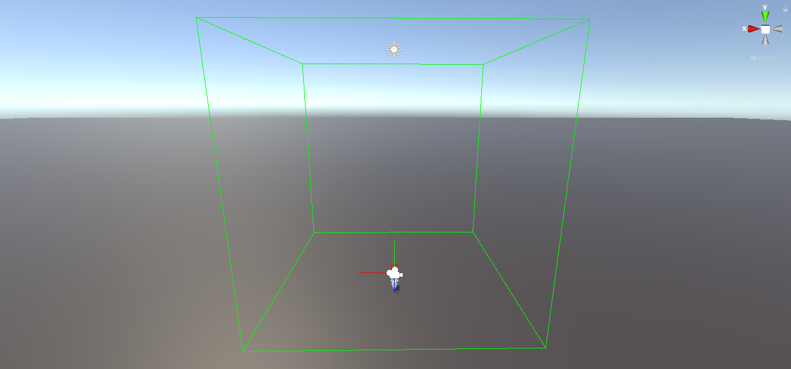

**Fig 1:** Room scale XR Rig this is the area the player designates as their room and is the area the player can walk around in freely.

Once the XR rig is set up and ready to go a tracked pose driver is added, this tracks the position of the player within the XR rig allowing for smooth movement throughout the game. An XR rig prebuilt script is attached onto the XR rig this controls the XR rig and its position as well as tracking if the player is on the floor and the position of the camera.

**7.2.3 adding more advanced features to the VR.**

After setting up the basic VR requirements more advanced features are required first the ability to pick up and drop items is created to do this a simple cube is created and a XR Grab interactable script is added this allows the player when close to pick up and drop the cube. Velocity tracking was enabled allowing the objects position to be tracked constantly making the telekinesis move smoothly.. After this realism was considered so to achieve this a hand was going to be used. A free hand model was downloaded from the Oculus website which anyone can use, each finger had to be set up with a separate capsule colliders for each joint on the fingers and a box collider for the palm so that it would look realistic when the player picks up an object, this was a slow process but rewarding as it made picking up objects greater. Graphical user interface
The hand joints were then rigged. An animation was originally added for opening and closing the hand however this was later removed as there was collision issues with it.

**Fig 2:** XR Grab interactable C# script.

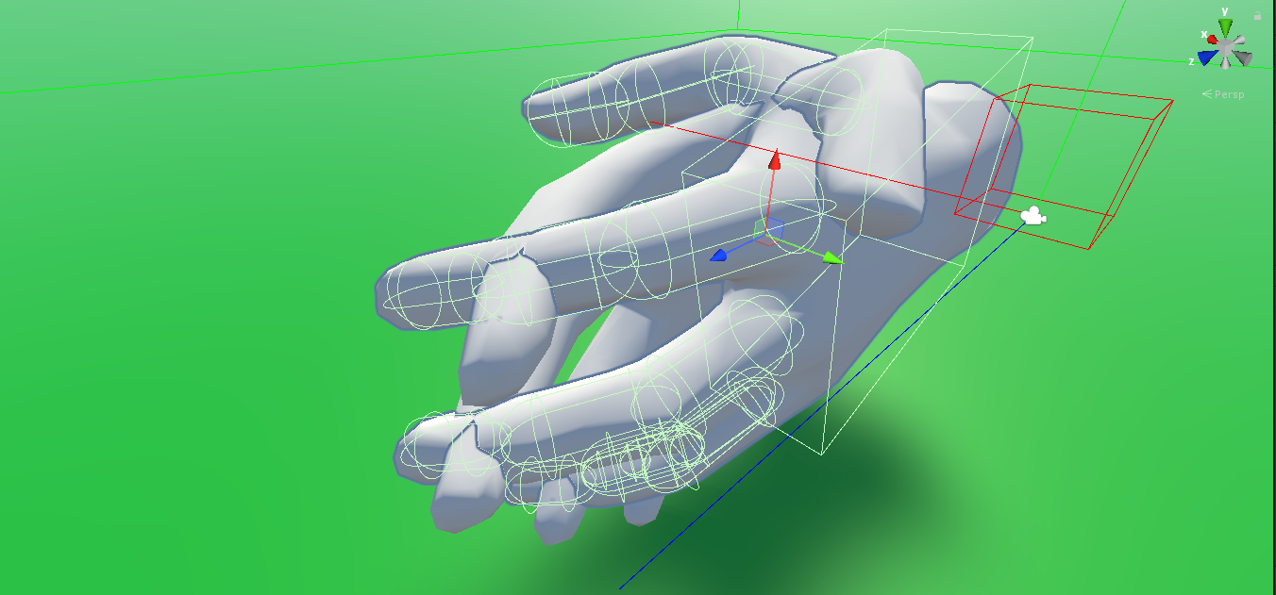

**Fig 3:** using hand models and adding colliders before then rigging them.

**Fig 4:** Using XR Rig and XR grab interactable to pick up an object.

**7.3 Environment**

**7.3.1 Level design**

When creating the environment realism and sense of scale was a big must have this was focused on to create the best experience for the player, the theme for the environment is a jungle/forest with a temple, within this temple would be puzzles the player must complete.

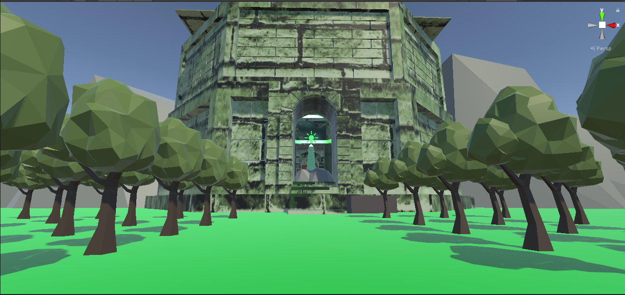

**Fig 5:** VR game environment, image of temple surrounded by trees.

The first environment was an office room this room was very basic and would just allow the player to familiarize themselves with the controls, once the player is ready to play the button will be pressed triggering the jungle level as shown by the image above.

**7.3.2 puzzle design**

Lots of research was done to decide what puzzle best suited this game and was most engaging and creative, after researching many puzzle mechanics forced perspective was the most interesting. The game that inspired this was ‘Superliminal’ and the idea would be that the objects scale according based on the distance between the players position and the objects position, in order to accomplish this the current position of the object would have to be stored and likewise for the player position, if the object is moving away from the player the object’s size is decreased and if its closer to the players position its size is increased, this allows the player to use objects to overcome puzzles and traverse the level. As well as using the telekinesis the player can also pick the objects up with the hands this will allow the movement of the objects without them scaling.

In order to do this the XR grab interactable script was used this allows the player to pick up the object from a certain distance which gives the effect of telekinesis, from this the player can then use the left controller stick to adjust the objects position bringing it closer or further away this would trigger the objects scale to change.

The player will navigate into the temple, once in the temple the player must rescale the objects to reach the next area which is high up and so will need to use the objects to reach it. Once that’s achieved the player will need to change the size of the key to fit the lock to unlock the door.

To create the forced perspective a C# script was created this would store all the values of the positions etc. and allow the objects to change shape in game time. The following code shows the picking up and dropping functions for the objects these are linked to event triggers on the XR grab interactable script and when an object is picked up the pickup function is triggered and likewise for the drop function. The C# script mainly uses two functions called Pickup()and Drop()Both of these are triggered from interactable events within the XR grab interactable script these functions handle what triggers the forced perspective.

<p>    
 curr_distance = Vector3.Distance(transform.position, playerCamera.transform.position);

transform.localScale = (transform.localScale / start_distance) * curr_distance;

</p>

This code above works out the current distance of the object from the player and Transform.localscale works out the scale of the object based on the local scale divided by the start distance multiplied by the current distance making the object scale based on how close or far away it is from the player.

<p>    
 public void Pickup()

{

Debug.Log("Picked up");

start_distance = Vector3.Distance

(transform.position, playerCamera

.transform.position);

Forcedperspective();

}

public void Drop()

{

Debug.Log("Dropped");

}

</p>

**7.3.3 Lighting**

For the VR game to look more real lighting was implemented this lighting wasn’t too complex but still makes a difference in making the world seem more alive which is the goal for this project. Lighting was added within the temple as the temple would be dark with only a few light sources and a torch which would illuminate around the player would be added. Within the temple there are a few lights one coming from the crystal in the centre which partly lights the temple as well as a few on the walls to help the player see where to go next.

**7.3.3 Sound**

Sound was also implemented to give the player a feel of being in the world footstep sounds were used however these were removed as issues with the sound system made the sounds not play most times the project was run this was later removed.

**8. Discussion of outcomes** 1600

This project has attempted to demonstrate a VR game using forced perspective, while the VR works very well with little to no issues there was issues with the forced perspective mechanic, this is due to a lot of the objects causing bugs when trying to scale them. Many methods were used to create this and almost all did not work, sometimes it would not be doing what it's supposed to do and other times even causing crashes. The VR is smooth which can help mitigate motion sickness, this could be used within other VR games that maybe lack this and due to that can possibly prevent motion sickness. Another issue faced during the project was a hardware problem as Oculus VR and unity seem to have a lot of issues with connectivity this would cause freezing and crashing a lot, but this won't be an issue if the project is built as it won't be using unity.

After attempting to implement everything stated in the research and findings the project has most of the criteria however preventing motion sickness was difficult to overcome due to certain headsets having built in capabilities to prevent this, a teleporting system could have been implemented using the locomotive system or teleportation provider which comes as default with XR packages, however this was not implemented. This project could be improved upon to make it more engaging. Smooth and easy to use VR controls were achieved which was the biggest hurdle due to the amount of knowledge needed to understand it and the vast number of settings that had to be changed as well as there being a huge amount of different control schemes to choose from for all the different VR headsets. Even though the VR system is good lots could be improved on most of all mitigating motion sickness as this was left to the end and so wasn’t as good as originally planned. A teleport system like the game half-life Alex would have been a good base as it uses a line which is visible to the player showing where to teleport to and the player only has to press a button and is moved to that position in the game world, this would reduce nausea and make players more comfortable.

One main flaw with this project was the forced perspective system as issues would arise often one being that the shape would shrink on its own when picked up and would shrink until it’s so small it wasn’t visible anymore, this would not allow the player to resize it bigger. This would pose a big issue as the player would no longer be able to continue the game and would then render the game unplayable. The lighting and textures were also a flaw as they were left to the end and so were rushed and did not end up as good as originally intended.

**Fig 7:** Textures from the walls of the temple. This shows the textures being stretched these could have been improved on to make them look a better quality..

This project could be improved on in environmental details sound, textures and lighting the project had no sounds due to issues and the lighting was very bare minimum due to a lot of it being removed last minute. Textures were also a bit stretched and looked rushed. The models were good, but they were a little bit simple and the quality of life in the level wasn’t to the desired goal.

Another issue I’ve come across is if the headset and hands aren’t picked up straight away when starting the game, the hands will spawn on the ground causing them to partly clip through the floor making them stuck on the ground this rarely occurs but is a big issue when it does as the player can no longer play which both ruins the game and the experience. The project has a jump control as well however if the player jumps and presses it repeatedly at a fast speed the player will jump repeatedly. This can happen until the player stops, this isn’t game breaking and only goes to a certain height which isn’t too high however it still is an issue that should be fixed. This issue is caused within the player controller script because the XR rig thinks the player is still on the ground until a certain height is achieved.

Collision was also a big issue as adding collision between an object and the XR rig is very difficult as it uses the hand and camera as the collision this works however it can cause issues for example the players is able to put their head through the walls this can break immersion however this doesn’t happen very often only in certain areas of a wall.

Overall, the project has attempted to implement all the required systems and mechanics. The VR has been created to a good standard and works as intended, the forced perspective has a lot of issues the player is able to pick it up using telekinesis and the movement is smooth however forced perspective poses a lot of issues. This project attempts to overcome each of the research questions, only question that hasn’t been achieved is ‘How will the forced perspective mechanic be improved compared to other forced perspective games?’ the reason for this is due to the issues with forced perspective so this hasn’t made the mechanic better than other games that use this puzzle style. A check for the play area could have been created as well to reduce the chance of the player hitting or walking into something within their play area which could help reduce injuries. This could be added to improve risks of injury and improve immersion. An animation was originally used for the hand this could be added back and improved on to make the picking up of object more realistic instead of an object sticking to the palm of the hand.

**9. Conclusion and recommendations** 300

This project could be further worked on beyond UWE as a VR game as it has potential as puzzle VR games are very popular. This project could be used within a competition and a portfolio to show ways VR can be set up in Unity and give people more understanding on what to do in order to allow VR to work on this software.

Improvements could be implemented for future work on this project most improvements would be for quality of life within the environment and improving and fixing bugs with the forced perspective mechanic. More unique puzzles could also be added making the game more engaging and less repetitive as eventually it would get very boring.

Overall, this project helped a lot in understanding and learning how to create and implement VR in games for Unity which could help for future projects. However, there were lots of issues that are still present but from these issues lots have been researched and more knowledge has been gained about VR and creating VR games.

A motion sickness mode could be created allowing a player to play while sat down or teleport instead of walking these could be improved on to make a more flushed out VR game and improving comfortability when playing. And a minimum room size could be made so the player must have a certain play area to begin.

An animation for the players hands would have been a good addition so that it would close the hand when the player closes his/her hand and same for when the player opens their hand, this was originally planned and partly implemented however it was removed as it would cause collision issues as the hand is made up of many separate colliders.

**10. References** (=not included in word count – these are the sources you are actually quoting in this report; in alphabetical order)

Arvilab.com, (2018) Combating Vr Sickness: Debunking Myths and Learning What Really Works. [online]. [Accessed 17 December 2021].

<https://vr.arvilab.com/blog/combating-vr-sickness-debunking-myths-and-learning-what-really-works>

Sciencedaily.com, (2020) Virtual Reality, Real Injuries: How to Reduce Physical Risk in Vr. [online]. [Accessed 17 December 2021].

<https://www.sciencedaily.com/releases/2020/01/200108092448.htm>

Helen A. Lee, (2020) The Real Reason Vr Makes Some People Sick. Simulator Sickness Has Long Been an Issue [online]. [Accessed 14 December 2021].

<https://www.looper.com/215435/the-real-reason-vr-makes-some-people-sick/>

Reportlinker, (2021) Yahoo! Finance. Virtual Reality (Vr) Market - Growth, Trends, Covid-19 Impact, and Forecasts (2021 - 2026) [online]. [Accessed 15 December 2021].

<https://finance.yahoo.com/news/virtual-reality-vr-market-growth-121600692.html?guccounter=1>

Circuitstream, (2021) Unity Vs Unreal Engine For Xr Development: Which One Is Better? [2021 Updated]. Summary [online]. [Accessed 17 December 2021].

<https://circuitstream.com/blog/unity-vs-unreal/>

Krueger, K.K. and Corso, K.C. (2022) Virtual Reality Leads to Real Injuries. [online].

<https://www.local10.com/health/2022/02/17/virtual-reality-leads-to-real-injuries/>

Whittaker, K.W. (2019) How to Stop Motion Sickness From Video Games. What Is Motion Sickness and How Do Video Games Cause It? [online]. [Accessed 17 December 2021].

<https://www.ghostgb.co.uk/how-to-stop-motion-sickness-from-video-games/>

**11. Bibliography** (=not included in word count – these are any further items you have read around this topic; in alphabetical order)  
Author, A. (2009) *A Book About Student Projects*. Location Publisher.

Author, B (2008) ‘Journal Article’, *Digital Media Journal*, Vol 1/13, pp 13-23

University of the West of England (2009) *UWE Library Services:Study skills - The Harvard System* [Online] Available from <https://www1.uwe.ac.uk/students/studysupport/studyskills/referencing/uwebristolharvard.aspx>

[last access: 23 September 2009]

**Appendix A: Project Log** (not included in word count)

**Appendix B: Project Timeline** (not included in word count)

**Appendix C: Assets used in the Project** (not included in word count)

This is a list of project assets: all source materials used in the project. Clearly state which were produced by yourself and which were not. If not produced by yourself, include their reference, and status with regard to copyright/ creative commons licensing.

**Further Appendixes D, E … if applicable**\*(not included in word count)  
What could go here?

* Ethics: participant info sheets, consent form, interview questions, anonymized matrices, other anonymized summaries or analyses
* Any important design documents too large to insert in the main text
* Any important code sections not already on GitHub
* Any impotant large tables or diagrams
* Other relevant materials

*only insert meaningful materials here, please don’t just bulk this report up. Your main text should be able to stand on its own, without relying on information contained in appendixes. Check with your supervisor beforehand.